Indian Institute of Technology Kharagpur
Department of Humanities and Social Sciences

Class Test - I Full Marks: 20 Time: 1hr. Date: 21/02/2022 (Monday)
Subject No: HS20202/HS41002 Subject Name: Econometric Analysis I

Instructions: Answer all the questions. Write the answers in sequence of the question paper. Submit the Answer Script within the given timeline in MS Teams only. Submission through email or late submission will not be considered.

Group A - Select the most appropriate alternative for the following: 1×14 = 14

- When the explanatory variable of a regression model is “non-stochastic”, it is:
- Partly random
- Fixed in repeated samples
- Correlated with the errors
- Always confined to a value of unity

- If a hypothesis test is conducted using the 5 percent significance level:
- It is equal to the size of the test
- It is equal to the power of the test
- 2.5 percent of the total distribution will be in the rejection region of each tail for a two-tailed test
- 5 percent of the total distribution will be in the rejection region of each tail for a two-tailed test

- (ii) and (iv) only
- (i) and (iii) only
- (i), (ii) and (iii) only
- (i), (ii), (iii) and (iv)

- The slope of a bivariate linear regression model cannot be estimated if:
- The independent variable takes the same value across all the observations
- The variance of independent variable is maximized
- The independent variable takes values as reciprocal of the dependent variable
- None of the above

- The method of ordinary least squares helps in:
- Minimising the distance across the data points
- Finding the values of the regression coefficients
- Finding the values of the regression coefficients with the smallest values of the residual sum of squares
- Finding the values of regression coefficients with the smallest sum of the residuals

- In regression analysis, the scatter plot around the regression line is measured by the:
- Explained sum of squares
- Unexplained sum of squares
- Mean value of the dependent variable
- None of the above

- If the computed value of the F statistic is greater its critical value, it implies that:
- None of the independent variables has a significant effect
- One or more independent variables have a significant effect
- All the independent variables have a significant effect
- None of the above

- Which of the following is true for R²?
a) It is also known as the standard error of the regression
b) A low value R² indicates that the estimated model should be discarded
c) The value of R² usually decreases with inclusion of additional independent variables
d) It shows the percentage of total variations in the dependent variable that is explained by the explanatory variable(s).

- If a multiple regression model has a very high R², but none of the slope coefficients is significantly different from zero, it indicates that:
a) The explanatory variables are highly collinear
b) The dependent variable does not vary by much
c) The intercept has been omitted from the model
d) The explanatory variables are highly orthogonal

- The standard error of an estimated regression model measures the:
- Variability of the dependent variable relative to the estimated regression line
- Variability of the independent variable(s) relative to its(their) mean
- Variability of the dependent variable relative to its mean
- The average error that will result if the regression line is used for prediction

- The adjusted value of the coefficient of determination:
- Will always increase with inclusion of additional independent variables to the model
- Is equal to the proportion of variations of the dependent variable explained by the regression model
- Is always greater than the proportion of variations of the dependent variable explained by the regression model
- Is always less than the proportion of variations of the dependent variable explained by the regression model

- Which of the following would be the consequences of violating one or more assumptions of the classical linear regression model (CLRM)?
- The estimated coefficients are not optimal
- The estimated standard errors are not optimal
- The statistical distributions assumed for the test statistics are inappropriate
- Conclusions on the relationships between the dependent and the independent variables may be invalid

- ii and iv only
- i and iii only
- i, ii, and iii
- i, ii, iii, and iv

- Which of the following statements is true about the regression line?
- A regression line indicates the average relationship
- A regression line is also known as the estimating equation
- A regression line can also be termed as the prediction equation
- All of the above

- In a linear regression model, when an additional independent variable is included:
- Its coefficient will be significant if the value of the R² increases
- Its coefficient will not be significant if the value of the R² decreases
- The importance of a variable cannot be judged only on the basis of R² value
- None of the above

- Consider the following two statements:
- If the null hypothesis is rejected in one-tailed test, it will be rejected in two-tailed test as well at the same significance level
- For the chosen significance level, the critical value of the t statistic gets closer to zero as the sample size increases

- Both statements are true
- Neither of the statements is true
- Only the first statement is true
- Only the second statement is true
Group B - Answer the following questions: 2 × 3 = 6

- Assume that initially the bivariate model 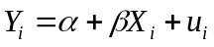 is estimated. However, when an additional independent variable 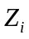 is added to this model and the new model 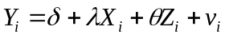is estimated, the sign of the coefficient of 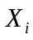 changes. What may be the possible reason(s) for such a finding? Justify your answer with a suitable example.

Answer: Possibility of severe multicollinearity betweenand 
Example: Sales of a firm being a function of advertising efforts and in-house R&D
Consider the following models:
(1)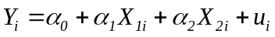; (2)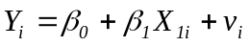; (3) 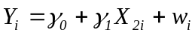
(4)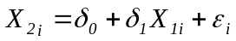; (5) 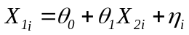
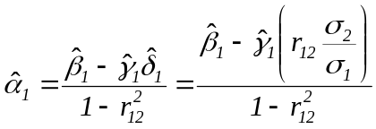 and 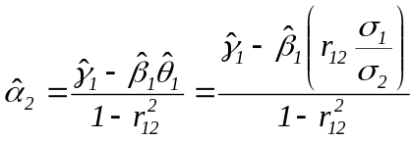
Here, 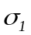 = standard deviation of 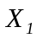; 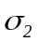= standard deviation of 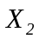
Clearly, when 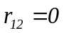, 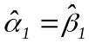 and 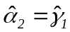
When 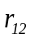 is very high and 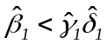 (or 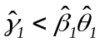), 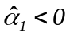(or 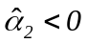) even if 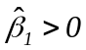 (or 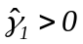)

- While computing the variance inflation factors (VIFs) of the independent variables in a multiple regression model, should one use adjusted 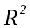 instead of the ordinary of the auxiliary regressions? Justify your answer.

The VIFs are computed using the adjusted and not the ordinaryof the auxiliary regression models.

Consider the following models: (1); (2)
Here, 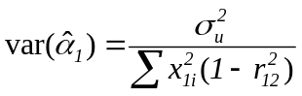 and 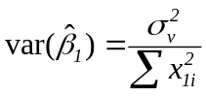
Hence, 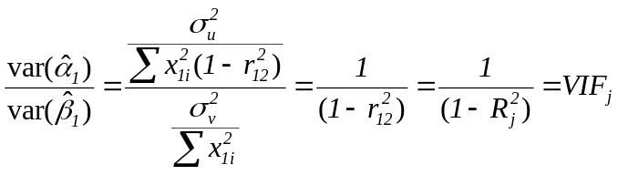 (assuming that 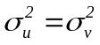)
Further, since the ordinaryhas generally higher value, the VIFs will also be higher vis-à-vis when adjustedis used. This increases the probability of the computed VIFs exceeding the threshold. Despite this, if the computed VIFs are less that the threshold, the conclusion on no severe multicollinearity will be more robust.

- Suppose while testing the hypothesis 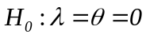 for the model, it is found that the null hypothesis is rejected at 5 percent significance level. However, it is not so when 1 percent significance level is considered. What should be concluded in such a case? Give justification in support of your answer.

Answer:

While testing the hypothesis for the model, 1 percent significance level is always preferred to the 5 percent significance level. This is so because 1 percent significance level has wider confidence interval and hence there is larger chance that the null hypothesis will not be rejected. Despite this, if the null hypothesis is rejected, the conclusion on statistical significance of the estimated model is more robust.

However, 5 percent significance level is a widely used significance level as it results in reasonable confidence limits. Hence, in the present case, it may be concluded that the estimated model is statistically significant.
_____________

